- \Operation\Tube infeed\Tube infeed
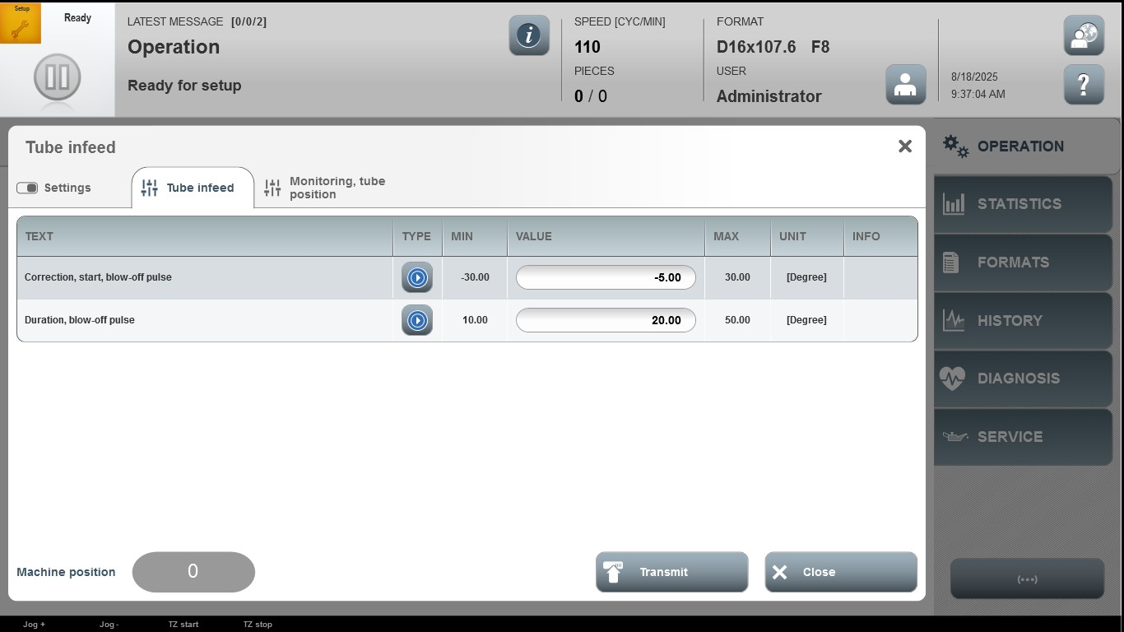

Acceptance criterion | Limits | Pass / Fail: Dev-No. | Date | Initials
Screen matches screenshot | N / A
Correction, start, blow-off pulse | -30.00 … 30.00
Duration, blow-off pulse | 10.00 … 50.00

